Title: **Wheatstone Bridge** Test: 8

Course: Electrical Applications Unit: Electrical Theory CLO: 3

Name _________________________ Grade ________ Date ______________

**Objectives**

1. Student shall determine the value of an unknown resistance given a Wheatstone bridge.
2. Student shall analyze that value of a Wheatstone bridge in appropriate field applications.
3. Student shall identify specific characteristics of a Wheatstone bridge.

**Assessment**

Students shall demonstrate a comprehension of the objectives listed above by scoring a minimum of 75% on this Test. Grading shall be based on an answer key.

**Circuit**

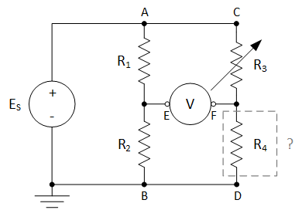

$$Where: E_{S}=20V, R_{1}=3kΩ, R_{2}=2kΩ,R_{3}=330Ω, E_{EF}=4.609V$$

**Instructions**

Using the formulas on the previous page and the given values above, complete the following table.

|  |  |  |  |  |
| --- | --- | --- | --- | --- |
|  | P | I | R | E |
| R1 |  |  |  |  |
| R2 |  |  |  |
| R3 |  |  |  |  |
| R4 |  |  |  |

Calculate the value that R3 would need to be adjusted to obtain a balanced bridge circuit.

|  |  |  |  |  |
| --- | --- | --- | --- | --- |
|  | P | I | R | E |
| R1 |  |  |  |  |
| R2 |  |  |  |
| R3 |  |  |  |  |
| R4 |  |  |  |

**Circuit**



$$Where: E_{S}=15V, R_{1}=10kΩ, R_{2}=22kΩ,R_{3}=1kΩ, E_{EF}=-0.653V$$

Using the formulas on the previous page and the given values above, complete the following table.

|  |  |  |  |  |
| --- | --- | --- | --- | --- |
|  | P | I | R | E |
| R1 |  |  |  |  |
| R2 |  |  |  |
| R3 |  |  |  |  |
| R4 |  |  |  |

Calculate the value that R3 would need to be adjusted to obtain a balanced bridge circuit.

|  |  |  |  |  |
| --- | --- | --- | --- | --- |
|  | P | I | R | E |
| R1 |  |  |  |  |
| R2 |  |  |  |
| R3 |  |  |  |  |
| R4 |  |  |  |

**Characteristics**

Answer each multiple-choice question below based on the characteristics of a balanced Wheatstone bridge.

1. If the value of R4 increased, to obtain a balanced bridge R3 would have to?
   1. Increase
   2. Decrease
   3. Remain the same
2. If the value of EF was larger than that of EE, R3 would need to ____ to balance the bridge voltage.
3. Increase
4. Decrease
5. Remain the same
6. If the bridge is balanced and the supply voltage ES is increased, the bridge voltage would?
7. Increase
8. Decrease
9. Remain the same